1. **Program for AWT KeyEvent.**

import java.awt.*;

import java.awt.event.*;

import java.applet.*;

/*

<applet code="_01_Keyboard_Events" width="400" height="100" > </applet>

*/

// In case of Applet need to declare class Public else applet will not be able to access class

// KeyListener is from awt.event.KeyListener

public class _01_Keyboard_Events extends Applet implements KeyListener{

String msg = "";

// init is from java.applet.Applet

public void init(){

addKeyListener(this);

requestFocus();     //*** what is this doing ***

}

@Override

public void keyPressed(KeyEvent e) {

// showStatus was from java.applet.Applet

showStatus(e.getKeyChar() + " key down");

}

@Override

public void keyReleased(KeyEvent e) {

showStatus(e.getKeyChar() + " key up");

}

// repaint was from awt.Component.repaint

@Override

public void keyTyped(KeyEvent e) {

// showStatus(e.getKeyChar() + " key typed");

msg += e.getKeyChar();

repaint();

}

// output text you typing

public void paint(Graphics g){

g.drawString( msg, 10, 20 );

}

}

**Output:**

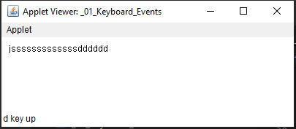

1. **Program for AWT MouseEvent, MouseMotionEvent.**

import java.awt.*;

import java.awt.event.*;

import java.applet.*;

/*

<applet code="_02_Mouse_Events" height="200" width="400" ></applet>

*/

public class _02_Mouse_Events extends Applet implements MouseListener, MouseMotionListener {

int X, Y;

public void init(){

addMouseListener(this);

addMouseMotionListener(this);

}

@Override

public void mouseClicked(MouseEvent e) {

showStatus("Mouse clicked");

}

@Override

public void mouseEntered(MouseEvent e) {

showStatus("Mouse Entered");

}

@Override

public void mouseExited(MouseEvent e) {

showStatus("Mouse Exited");

}

// *****  ?  *****

@Override

public void mousePressed(MouseEve­­nt e) {

showStatus("Mouse Pressed");

}

@Override

public void mouseReleased(MouseEvent e) {

showStatus("Mouse Release");

}

@Override

public void mouseDragged(MouseEvent e) {

showStatus("Mouse Dragged, e-> X:" + e.getX() + ", Y: " + e.getY());

X = e.getX();

Y = e.getY();

repaint();

}

@Override

public void mouseMoved(MouseEvent e) {

showStatus("Mouse Moved");

}

public void paint(Graphics g){

g.drawString(X +" "+ Y, X, Y);

}

}

**Output:**

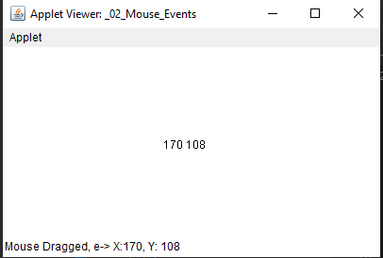

1. **Program for AWT Labels.**

import java.awt.*;

import java.applet.*;

// <applet code="_03_Label" height="300"width="300" > </applet>

public class _03_Label extends Applet {

Label l1, l2, l3;

public void init(){

l1 = new Label("Shubham");

l2 = new Label("Dahiya");

l3 = new Label("HIM");

// adding to the window of applet

add(l1);

add(l2);

add(l3);

}

}

**Output:**

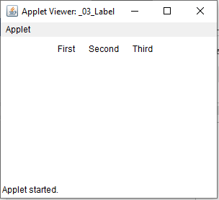

1. **Program for AWT Button & ActionEvent.**

import java.awt.*;

import java.awt.event.*;

import java.applet.*;

// <applet code="_04_Button" height="200"width="300" > </applet>

public class _04_Button extends Applet implements ActionListener {

Button b1, b2, b3;

String msg = "";

public void init(){

b1 = new Button("Shubham");

b2 = new Button("Dahiya");

b3 = new Button("HIM");

// adding to applet

add(b1);

add(b2);

add(b3);

b1.addActionListener(this);

b2.addActionListener(this);

b3.addActionListener(this);

}

@Override

public void actionPerformed(ActionEvent e) {

msg = "you pressed " + e.getActionCommand();

showStatus("you pressed " + e.getActionCommand() );

repaint();

}

public void paint(Graphics g){

g.drawString(msg, 10, 100);

}

}

**Output:**

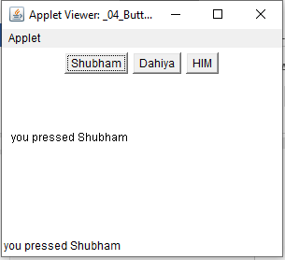

1. **Program for AWT TextField.**

import java.awt.*;

import java.awt.event.*;

import java.applet.*;

// <applet code="_05_TextField" height="200"width="400" > </applet>

public class _05_TextField extends Applet implements ActionListener{

TextField name, password;

Label l1, l2;

String s1= "", s2 ="";

public void init(){

l1 = new Label("name", Label.LEFT);

l2 = new Label("password", Label.RIGHT);

name= new TextField(12);

password= new TextField(12);

add(l1);

add(name);

add(l2);

add(password);

name.addActionListener(this);

password.addActionListener(this);

}

@Override

public void actionPerformed(ActionEvent e) {

s1 = "name:" + e.getActionCommand();

s2 = "Password: " +e.getActionCommand();

repaint();

}

public void paint(Graphics g){

g.drawString(s1, 10, 100);

g.drawString(s2, 10, 120);

}

}

**Output:**

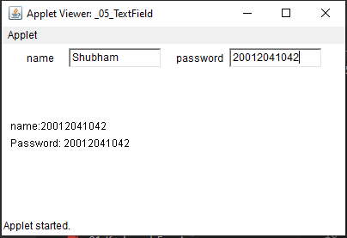

1. **Program for AWT List.**

import java.awt.*;

import java.awt.event.*;

import java.applet.*;

// <applet code="_06_List" height="200"width="500" > </applet>

public class _06_List extends Applet implements ActionListener {

List grocery, dev_field;

public void init(){

grocery = new List(5, true);

dev_field = new List(4, false );

grocery.add("apple");

grocery.add("Mango");

grocery.add("Grapes");

grocery.add("Banana");

grocery.add("Pineapple");

grocery.add("Strawberry");

grocery.add("Pulse");

grocery.add("Ladyfinger");

grocery.add("Potato");

grocery.add("Tomato");

grocery.select(2);

dev_field.add("Web Development");

dev_field.add("Android Development");

dev_field.add("iOS Development");

dev_field.select(0);

add(grocery);

add(dev_field);

grocery.addActionListener(this);

dev_field.addActionListener(this);

}

@Override

public void actionPerformed(ActionEvent e) {

repaint();

}

public void paint(Graphics g){

String gr = "Current selcted groceries are: ";

int idx[] = grocery.getSelectedIndexes();

for(int i:idx)

gr+=grocery.getItem(i) +",";

String f = "Currently selected dev_field ";

f += dev_field.getSelectedItem();

g.drawString(gr, 10, 100);

g.drawString(f, 10, 120);

}

}

**Output:**

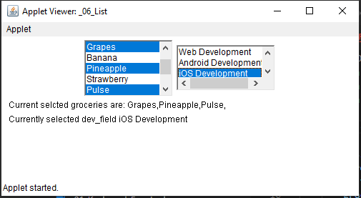

1. **Program for AWT Checkbox & ItemEvent.**

import java.awt.*;

import java.awt.event.*;

import java.applet.*;

// <applet code="_07_Checkbox" height="200"width="400" > </applet>

public class _07_Checkbox extends Applet implements ItemListener {

Checkbox apple, mango, grapes, banana;

public void init(){

apple = new Checkbox("apple");

mango = new Checkbox("mango");

grapes = new Checkbox("grapes", null, true);

banana = new Checkbox("banana");

add(apple);

add(mango);

add(grapes);

add(banana);

apple.addItemListener(this);

mango.addItemListener(this);

grapes.addItemListener(this);

banana.addItemListener(this);

}

@Override

public void itemStateChanged(ItemEvent e) {

repaint();

}

public void paint(Graphics g){

String ap = "apple: ";

ap += apple.getState();

g.drawString(ap, 10, 100);

String ma = "mango: ";

ma += mango.getState();

g.drawString(ma, 10, 115);

String gr = "grapes: ";

gr += grapes.getState();

g.drawString(gr, 10, 130);

String ba = "banana: ";

ba += banana.getState();

g.drawString(ba, 10, 145);

}

}

**Output:**

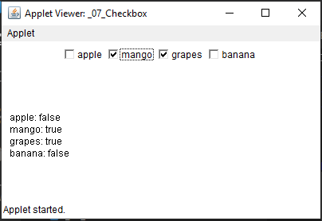

1. **Program for AWT RadioButton & ItemEvent.**

import java.awt.*;

import java.awt.event.*;

import java.applet.*;

// <applet code="_08_Radio_Checkbox" height="200"width="500" > </applet>

public class _08_Radio_Checkbox extends Applet implements ItemListener{

Checkbox apple, mango, grapes, banana;

CheckboxGroup group;

public void init(){

group = new CheckboxGroup();

apple = new Checkbox("apple", group, false);

mango = new Checkbox("mango", group, false);

grapes = new Checkbox("grapes", group, true);

banana = new Checkbox("banana", group, false);

add(apple);

add(mango);

add(grapes);

add(banana);

apple.addItemListener(this);

mango.addItemListener(this);

grapes.addItemListener(this);

banana.addItemListener(this);

}

@Override

public void itemStateChanged(ItemEvent e) {

repaint();

}

public void paint(Graphics g){

String str = "currently selected: ";

str += group.getSelectedCheckbox().getLabel();

g.drawString(str, 10, 100);

}

}

**Output:**

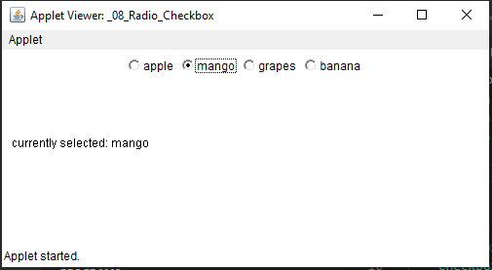

1. **Program for AWT Scroll & AdjustmentEvent.**

import java.awt.*;

import java.awt.event.*;

import java.applet.*;

// <applet code="_09_scroll" height="300"width="300" > </applet>

public class _09_scroll extends Applet implements AdjustmentListener {

Scrollbar hsb, vsb;

int x = 0, y = 0;

public void init(){

vsb = new Scrollbar(Scrollbar.VERTICAL,0, 70, 0, 300);

hsb = new Scrollbar(Scrollbar.HORIZONTAL,0, 70, 0, 300);

vsb.setBounds(300, 300, 500, 300);

hsb.setBounds(300, 300, 500, 300);

add(hsb);

add(vsb);

vsb.addAdjustmentListener(this);

hsb.addAdjustmentListener(this);

}

@Override

public void adjustmentValueChanged(AdjustmentEvent e) {

// if( e.get)

// x = e.getValue();

repaint();

}

public void paint(Graphics g){

x = hsb.getValue();

y = vsb.getValue();

showStatus(x + " " + y);

g.drawString("*", x, y);

}

}

**Output:**

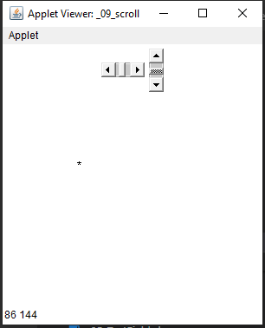

1. **Program for AWT TextArea & TextEvent.**

import java.awt.*;

import java.awt.event.*;

import java.applet.*;;

// <applet code="_10_Textarea" height="250"width="500" > </applet>

public class _10_Textarea extends Applet implements TextListener{

TextArea a;

public void init(){

a = new TextArea("Hello start with this");

a.setColumns(27);

a.setRows(5);

add(a);

a.addTextListener(this);

}

@Override

public void textValueChanged(TextEvent e) {

repaint();

}

public void paint(Graphics g){

String s = a.getText();

g.drawString(s, 10, 200);

}

}

**Output:**

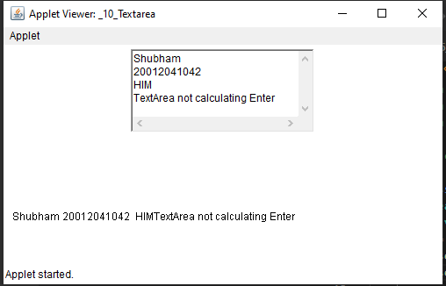

**Swings Program**

1. **Program for Swing JLabel**

import javax.swing.*;

class _11_JLabel{

JFrame jframe;

_11_JLabel(){

jframe = new JFrame("My First Frame in Swing - Shubham");

jframe.setSize(300, 400);

jframe.setVisible(true);

JLabel label1 = new JLabel("Shubham Dahiya - 20012041042");

jframe.add(label1);

}

public static void main(String[] args){

SwingUtilities.invokeLater(new Runnable(){

public void run(){

new _11_JLabel();

}

});

}

}

**Output:**

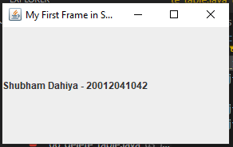

1. **Program for Swing JButton**

import java.awt.*;

import java.awt.event.*;

import javax.swing.*;

public class _12_JButton implements ActionListener {

JFrame jframe;

JButton btn1, btn2;

JLabel jLabel;

_12_JButton(){

jframe = new JFrame("JButton | Shubham");

jframe.setSize(500, 400);

jframe.setVisible(true);

jframe.setDefaultCloseOperation(JFrame.EXIT_ON_CLOSE);

jframe.getContentPane().setLayout(new FlowLayout());

btn1 = new JButton("First Btn");

btn2 = new JButton("Second Btn");

btn1.addActionListener(this);

btn2.addActionListener(this);

btn1.setBounds(10, 20, 100, 40);

btn2.setBounds(40, 20, 100, 40);

btn2.setSize(50, 10);

jLabel = new JLabel("Press a button");

jframe.add(btn1);

jframe.add(btn2);

jframe.add(jLabel);

}

int a = 0, b = 0;

@Override

public void actionPerformed(ActionEvent e) {

if( e.getActionCommand().equals("First Btn")){

jLabel.setText(e.getActionCommand() + " is pressed " + a++ + " times");

}

if( e.getActionCommand().equals("Second Btn")){

jLabel.setText(e.getActionCommand() + " is pressed " + b++ + " times");

}

}

public static void main(String[] args) {

SwingUtilities.invokeLater(new Runnable(){

public void run(){

new _12_JButton();

}

});

}

}

**Output:**

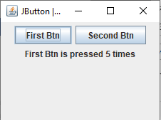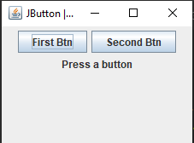

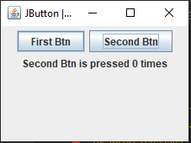

1. **Program for Swing JCheckBox**

import javax.swing.*;

import java.awt.event.*;

import java.awt.*;

public class _13_JCheckBox extends JFrame

{

public _13_JCheckBox()

{

//creating JCheckBox.

JCheckBox jcb = new JCheckBox("First");

//adding JCheckBox to frame.

add(jcb);

jcb = new JCheckBox("Second");

add(jcb);

jcb = new JCheckBox("Dahiya");

add(jcb);

setLayout(new FlowLayout());

setDefaultCloseOperation(JFrame.EXIT_ON_CLOSE);

setSize(400, 100);

setVisible(true);

}

public static void main(String[] args)

{

new _13_JCheckBox();

}

}

**Output:**

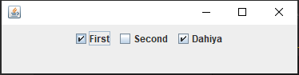

1. **Program for Swing JTextField**

import javax.swing.*;

import java.awt.event.*;

import java.awt.*;

public class _14_JTextField extends JFrame

{

public _14_JTextField()

{

//creating JTextField.

JTextField jtf = new JTextField(20);

//adding JTextField to frame.

add(jtf);

setLayout(new FlowLayout());

setDefaultCloseOperation(JFrame.EXIT_ON_CLOSE);

setSize(400, 100);

setVisible(true);

}

public static void main(String[] args)

{

new _14_JTextField();

}

}

**Output:**

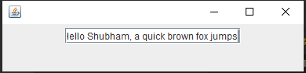

1. **Program for Swing JRadioButton**

import javax.swing.*;

import java.awt.event.*;

import java.awt.*;

public class _15_JRadioButton extends JFrame

{

public _15_JRadioButton()

{

//creating JRadioButton.

JRadioButton jcb = new JRadioButton("A.");

//adding JRadioButton to frame.

add(jcb);

jcb = new JRadioButton("B.");

add(jcb);

jcb = new JRadioButton("C.");

add(jcb);

jcb = new JRadioButton("D.");

add(jcb);

setLayout(new FlowLayout());

setDefaultCloseOperation(JFrame.EXIT_ON_CLOSE);

setSize(400, 100);

setVisible(true);

}

public static void main(String[] args)

{

new _15_JRadioButton();

}

}

**Output:**

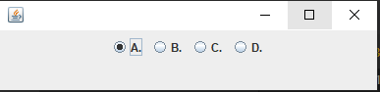 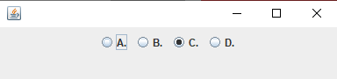

1. **Program for Swing JToggleButton**

import javax.swing.*;

import java.awt.*;

import java.awt.event.*;

public class _16_JToggleButton extends JFrame implements ItemListener{

private JToggleButton btn;

public _16_JToggleButton(){

setTitle("JToggleButton Example");

setLayout(new FlowLayout());

setJToggleButton();

setAction();

setSize(200, 100);

setVisible(true);

setDefaultCloseOperation(JFrame.EXIT_ON_CLOSE);

}

private void setJToggleButton() {

btn = new JToggleButton("Deselected");

add(btn);

}

private void setAction() {

btn.addItemListener(this);

}

public void itemStateChanged(ItemEvent eve) {

if (btn.isSelected())

btn.setText("Selected");

else

btn.setText("Deselected");

}

public static void main(String[] args) {

new _16_JToggleButton();

}

}

**Output:**

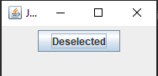 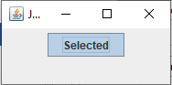

1. **Program for Swing JComboBox**

import javax.swing.*;

import java.awt.*;

import java.awt.event.*;

public class _17_JComboBox extends JFrame implements ItemListener {

// frame

static JFrame frame;

// combobox

static JComboBox combobox;

// label

static JLabel l1, l2;

public static void main(String[] args)

{

// create a new frame

frame = new JFrame("frame");

// create an object

_17_JComboBox obj = new _17_JComboBox();

// set the layout of the frame

frame.setLayout(new FlowLayout());

// array of strings containing languages

String s1[] = { "Java", "PHP", "Python", "C++", "Ruby" };

// create a checkbox

combobox = new JComboBox(s1);

// add ItemListener

combobox.addItemListener(obj);

// create labels

l1 = new JLabel("What is your favorite language? ");

l2 = new JLabel("[Java]");

// set the text color

l2.setForeground(Color.blue);

// create a new panel

JPanel p = new JPanel();

// add combobox and labels to the panel

p.add(l1);

p.add(combobox);

p.add(l2);

// add panel to frame

frame.add(p);

// set the frame size

frame.setSize(400, 200);

frame.show();

}

public void itemStateChanged(ItemEvent e)

{

// check if the state of the combobox is changed

if (e.getSource() == combobox) {

l2.setText(" ["+combobox.getSelectedItem()+"]");

}

}

}

**Output:**

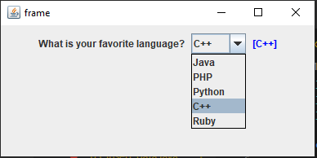 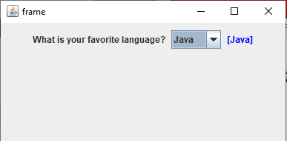

1. **Program for Swing JList**

import javax.swing.*;

public class _18_JList extends JFrame{

private JList<String> langages;

public _18_JList()

{

//create the model and add elements

DefaultListModel<String> model = new DefaultListModel<>();

model.addElement("Java");

model.addElement("JEE");

model.addElement("Python");

model.addElement("C++");

model.addElement("C#");

model.addElement("Pascal");

model.addElement("Ruby");

//create the list of languages

langages = new JList<>(model);

add(langages);

this.setTitle("JList Example");

this.setDefaultCloseOperation(JFrame.EXIT_ON_CLOSE);

this.setSize(200,200);

this.setLocationRelativeTo(null);

this.setVisible(true);

}

public static void main(String[] args)

{

SwingUtilities.invokeLater(new Runnable()

{

@Override

public void run()

{

new _18_JList();

}

});

}

}

**Output:**

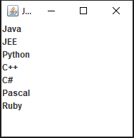

**Collection Framework**

1. **Program for ArrayList**

import java.util.ArrayList;

public class _19_ArrayList {

public static void main(String args[]) {

ArrayList<Integer> arrlist1 = new ArrayList<Integer>(5);

//add​(E e)

arrlist1.add(12);

arrlist1.add(20);

arrlist1.add(45);

System.out.println("Printing list1:"+arrlist1);

ArrayList<Integer> arrlist2 = new ArrayList<Integer>(5);

arrlist2.add(25);

arrlist2.add(30);

arrlist2.add(31);

System.out.println("\nPrinting list2:"+arrlist2);

//addAll​(int index, Collection<? extends E> c)

arrlist1.addAll(arrlist2);

System.out.println("\nPrinting all the elements"+arrlist1);

//contains​(Object o)

System.out.print("\nIs 30 present in the arraylist: ");

System.out.println(arrlist1.contains(30));

// indexOf​(Object o)

int pos =arrlist1.indexOf(45);

System.out.println("\nThe element 45 is at index : " + pos);

//isEmpty()

System.out.println("\nIs ArrayList Empty: "+arrlist1.isEmpty());

}

}

**Output:**

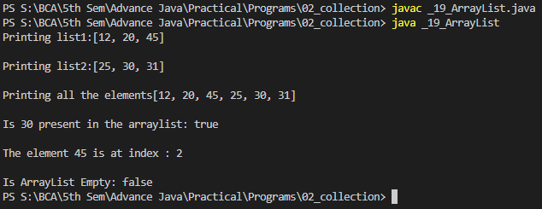

1. **Program for LinkedList**

import java.util.*;

public class _20_LinkedList{

public static void main(String args[]){

//linked list declaration syntax:

LinkedList <String> list = new LinkedList<String> ();

// addFirst, addLast, add :

list.addFirst("I");

list.addFirst("Hello!");

list.addLast("am");

list.add("a");

list.addLast("Linked list");

list.addLast("by");

list.add("using");

list.addLast("Classes");

list.addLast("Framework");

// print list and return size():

System.out.println(list);

System.out.println(list.size());

// remove() :

list.removeFirst();

list.remove(6);

list.remove(6);

list.remove(5);

list.removeLast();

System.out.println(list);

System.out.println(list.size());

}

}

**Output:**

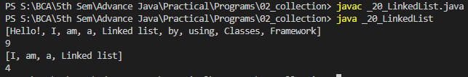

1. **Program for Stack**

import java.util.Stack;

public class _21_Stack {

public static void main(String[] args){

Stack<Integer> stack = new Stack();

stack.push(1);

stack.push(2);

stack.push(3);

stack.pop();

System.out.println("peek: " + stack.peek());

System.out.println("empty: " + stack.empty());

System.out.println("search 2: " + stack.search(2));

System.out.println("search 4: " + stack.search(4));

stack.pop();

stack.pop();

System.out.println("empty: " + stack.empty());

}

}

**Output:**

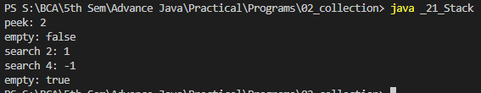

1. **Program for HashSet**

import java.util.*;

public class _22_HashSet {

public static void main(String[] args) {

// Hashset Declaratin and creating object.

Set<String> hashSet = new HashSet<String>();

// Adding elements to it

hashSet.add("White");

hashSet.add("Pink");

hashSet.add("Blue");

hashSet.add("Green");

hashSet.add("Yellow");

// Adding duplicates

hashSet.add("White");

hashSet.add("White");

hashSet.add("White");

hashSet.add("Yellow");

// Iterating HashSet to print its values.

Iterator<String> it = hashSet.iterator();

while (it.hasNext()) {

System.out.println(it.next());

}

}

}

**Output:**

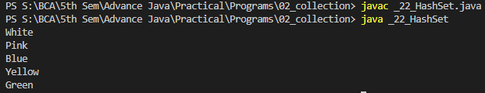

**JDBC**

**23. Program for JDBC Connection**

import java.util.*;

import java.sql.*;

class _01_connection{

public static void main(String[] args) {

try {

Class.forName("sun.jdbc.odbc.JdbcOdbcDriver");

Connection conn = DriverManager.getConnection("jdbc:odbc:shubham");

System.out.println("conn successful");

} catch (Exception e) {

System.out.println( "db not connected \nError is: " + e.getMessage());

}

}

}

**Output:**

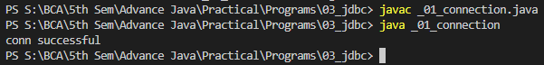

**24. Program for JDBC create table**

import java.util.*;

import java.sql.*;

class _02_create_table{

public static void main(String[] args) {

try {

Class.forName("sun.jdbc.odbc.JdbcOdbcDriver");

System.out.println("conn successful");

Connection conn = DriverManager.getConnection("jdbc:odbc:shubham");

Statement stmt = conn.createStatement();

// stmt.executeUpdate("create table HIM(SName String, SAge number, SCourse string )");

stmt.executeUpdate("create table HIM(SName text, SAge number, SCourse text )");

System.out.println("HIM table created");

} catch (Exception e) {

System.out.println( "Error is: " + e.getMessage());

}

}

}

**Output:**

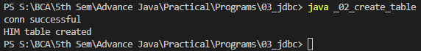

**25. Program for JDBC insert data**

import java.util.*;

import java.sql.*;

class _03_insert_data{

public static void main(String[] args) {

Scanner sc = new Scanner(System.in);

try {

Class.forName("sun.jdbc.odbc.JdbcOdbcDriver");

System.out.println("conn successful");

Connection conn = DriverManager.getConnection("jdbc:odbc:shubham");

// PreparedStatement ps = conn.prepareStatement("insert into HIM (SName, SAge, SCourse) values('Shubham', ?, 'BCA')");

// PreparedStatement ps = conn.prepareStatement("insert into HIM values('Shubham', 20, 'BCA')");

PreparedStatement ps = conn.prepareStatement("insert into HIM values( ?, ? , ?) ");

System.out.println("Enter name:");

String name = sc.next();

System.out.println("Enter age:");

int age = sc.nextInt();

System.out.println("Enter course:");

String course = sc.next();

ps.setString(1, name);

ps.setInt(2, age);

ps.setString(3, course);

// ps.setInt(1, 20);

ps.executeUpdate();

System.out.println("Data inserted in table");

conn.close();       // ----->  ********** most Important **********

} catch (Exception e) {

System.out.println( "db not connected \nError is: " + e.getMessage());

}

}

}

**Output:**

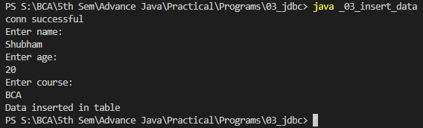

**26. Program for JDBC select table**

import java.util.*;

import java.sql.*;

class _04_select_table{

public static void main(String[] args) {

try {

Class.forName("sun.jdbc.odbc.JdbcOdbcDriver");

System.out.println("conn successful");

Connection conn = DriverManager.getConnection("jdbc:odbc:shubham");

Statement stmt = conn.createStatement();

ResultSet rs  = stmt.executeQuery("select * from HIM");

System.out.println("records in HIM table are: ");

while(rs.next()){

System.out.print( rs.getString(1) +"\t");

System.out.print( rs.getString(2) +"\t");

System.out.println( rs.getString(3) );

}

System.out.println("--- end ---");

} catch (Exception e) {

System.out.println( "db not connected \nError is: " + e.getMessage());

}

}

}

**Output:**

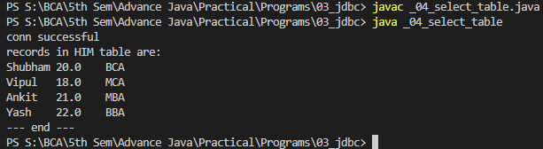

**27. Program for JDBC Update Table**

import java.sql.*;

public class _05_update_table {

public static void main(String[] args) {

try{

Class.forName("sun.jdbc.odbc.JdbcOdbcDriver");

Connection conn = DriverManager.getConnection("jdbc:odbc:shubham");

Statement stmt = conn.createStatement();

stmt.executeUpdate("update HIM set SName='Yashi',SCourse='MCA' where SAge=22 ");

conn.close();

System.out.println("Update successful");

}

catch(Exception e){

System.out.println("exception is: " + e.getMessage());

}

}

}

**Output:**

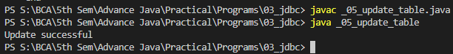

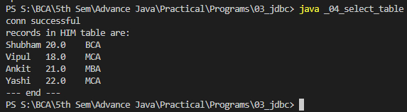

**28. Program for JDBC Delete Table**

import java.sql.*;

public class _06_delete_table {

public static void main(String[] args) {

try {

Class.forName("sun.jdbc.odbc.JdbcOdbcDriver");

Connection conn = DriverManager.getConnection("jdbc:odbc:shubham");

Statement stmt = conn.createStatement();

stmt.executeUpdate("delete from Him where Sname='Shubham'");

conn.close();

System.out.println("Delete Successful");

} catch (Exception e) {

System.out.println(e.getMessage());

}

}

}

**Output:**

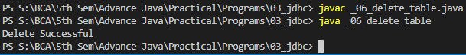

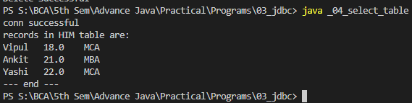

**Servlets**

**30. Program for Hello Servlet**

import java.io.*;

import javax.servlet.*;

import javax.servlet.http.*;

public class _01_HelloServlet extends HttpServlet {

public void doGet(HttpServletRequest req, HttpServletResponse res) throws ServletException, IOException{

res.setContentType("text/html");

PrintWriter out = res.getWriter();

out.println("<html>");

out.println("<body>");

out.println("<h1> Hello Shubham from Servlet");

out.println("</h1>");

out.println("</body>");

out.println("</html>");

}

}

**Output:**

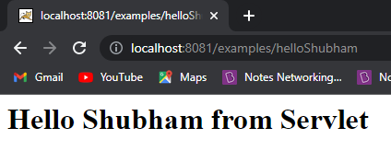

**31. Program for Reading Servlet Parameters**

**Html file**

<html>

<body>

<center>

<form name="form1" method="post" action="http://localhost:8081/examples/PostParametersServlet">

<table>

<tr>

 <td><B>Employee</td>

 <td><input type=textbox name="u_name" size="30" placeholder="Enter name here..."></td>

</tr>

<tr>

 <td><B>Phone</td>

 <td><input type=textbox name="u_password" size="30" placeholder="Enter phone no. here..."></td>

</tr>

</table>

<input type=submit value="Submit">

</form>

</center>

</body>

</html>

**Java file**

import java.io.*;

import javax.servlet.*;

import java.util.*;

public class _02_ReadiingServletParameters extends GenericServlet {

public void service(ServletRequest req, ServletResponse res) throws ServletException, IOException {

PrintWriter pw = res.getWriter();

Enumeration e = req.getParameterNames();

while(e.hasMoreElements()){

String name = (String) e.nextElement();

String value = (String) req.getParameter(name);

pw.println( name + " = " + value );

pw.println( "-------------------------------------" );

}

pw.close();

}

}

**Output:**

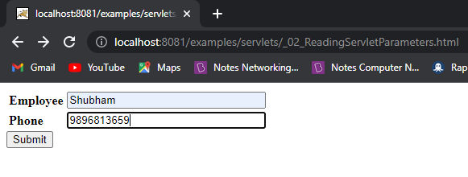

**onSubmit:**

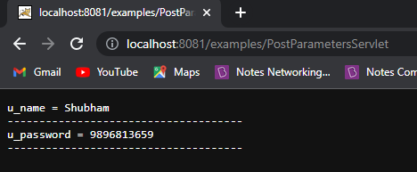

**32. Program for Reading Initialization Parameter**

import java.io.*;

import java.util.*;

import javax.servlet.*;

public class _03_ReadingInitalizationParameters extends GenericServlet{

public void service (ServletRequest req, ServletResponse res) throws ServletException, IOException {

res.setContentType("text/html");

PrintWriter pw = res.getWriter();

ServletConfig config = getServletConfig();

String name = (String) config.getInitParameter("name");

String roll = (String) config.getInitParameter("roll_no");

// ----------- or ------------

// String name = (String) getInitParameter("name");

// String roll = (String) getInitParameter("roll_no");

pw.println("<b> Name: </b>" + name);

pw.println("<b> Roll No. </b>: " + roll);

pw.close();

}

}

**Output:**

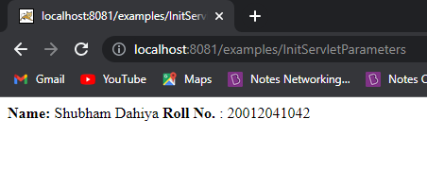

**33. Program for Handling Http Get Request**

**Html file**

<html>

<body>

<center>

<form name="form"

 action="http://localhost:8081/examples/HttpPostRequest">

<B>State:</B>

<select name="state" size="1">

<option value="J & K">J & K</option>

<option value="Delhi">Delhi</option>

<option value="Punjab">Punjab</option>

<option value="Haryana">Haryana</option>

<option value="Gujarat">Gujarat</option>

<option value="Bihar">Bihar</option>

<option value="UttarPradesh">UttarPradesh</option>

<option value="Uttarakhand">Uttarakhand</option>

<option value="Hyderabad">Hyderabad</option>

<option value="Goa">Goa</option>

<option value="Mumbai">Mumbai</option>

<option value="Sikkim">Sikkim</option>

<option value="Arunachal Pradesh">Arunachal Pradesh</option>

</select>

<br><br>

<input type=submit value="Submit">

</form>

</body>

</html>

**Java file**

import java.io.*;

import java.util.*;

import javax.servlet.*;

import javax.servlet.http.*;

public class _04_HandlingHttpGetRequest extends HttpServlet{

public void doGet(HttpServletRequest req, HttpServletResponse res) throws IOException, ServletException{

PrintWriter pw = res.getWriter();

res.setContentType("text/html");

String state = req.getParameter("state");

pw.println("<h1> The selected state is: </h1>");

pw.println( "<b><u>" + state + "</u></b>");

pw.close()

}

}

**Output:**

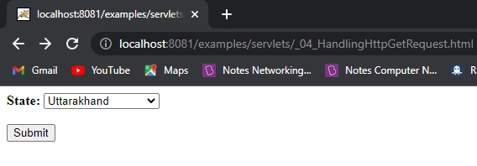

**onSubmit:**

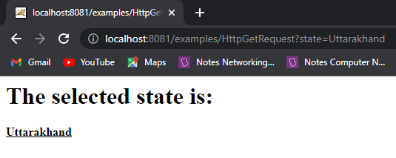

**34. Program for Handling Http Post Request**

**Html file**

<html>

<body>

<center>

<form name="form"

 method="post"

 action="http://localhost:8081/examples/HttpPostRequest">

<B>State:</B>

<select name="state" size="1">

<option value="J & K">J & K</option>

<option value="Delhi">Delhi</option>

<option value="Punjab">Punjab</option>

<option value="Haryana">Haryana</option>

<option value="Gujarat">Gujarat</option>

<option value="Bihar">Bihar</option>

<option value="UttarPradesh">UttarPradesh</option>

<option value="Uttarakhand">Uttarakhand</option>

<option value="Hyderabad">Hyderabad</option>

<option value="Goa">Goa</option>

<option value="Mumbai">Mumbai</option>

<option value="Sikkim">Sikkim</option>

<option value="Arunachal Pradesh">Arunachal Pradesh</option>

</select>

<br><br>

<input type=submit value="Submit">

</form>

</body>

</html>

**Java file**

import java.io.*;

import java.util.*;

import javax.servlet.*;

import javax.servlet.http.*;

public class _05_HandlingHttpPostRequest extends HttpServlet{

public void doPost(HttpServletRequest req, HttpServletResponse res) throws IOException, ServletException{

PrintWriter pw = res.getWriter();

res.setContentType("text/html");

String state = req.getParameter("state");

pw.println("<h1> The selected state is: </h1>");

pw.println( "<b><u>" + state + "</u></b>");

pw.close();

}

}

**Output:**

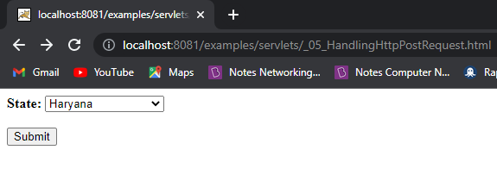

**onSubmit:**

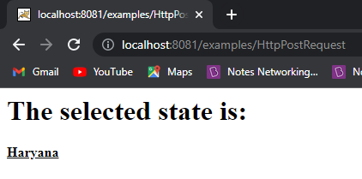

**JSP**

**35. Program for Hello JSP**

<html>

<body>

<% out.println("Hello Shubham's JSP."); %>

</body>

</html>

**Output:**

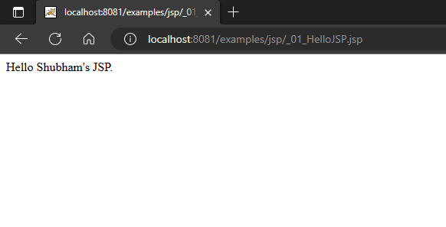

**36. Program for JSP Expression tag**

<html>

<body>

<%="Hello Shubham's JSP\n" %>

<br>

Date is: <%=java.util.Calendar.getInstance().getTime() %>

</body>

</html>

**Output:**

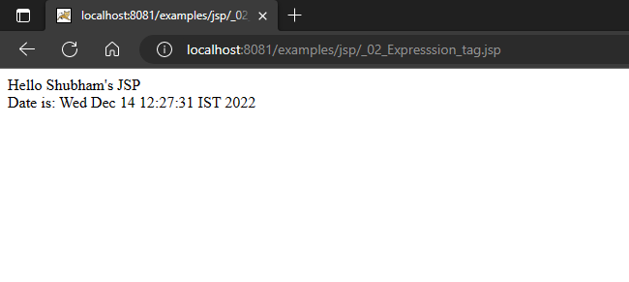

**37. Program for Variable Declaration in JSP**

<html>

<body>

<%!

int num = 10;

String s = "Shubham Dahiya, HIM, 20012041042";

%>

num is: <%= num %>

<br>

String s is: <%= s %>

</body>

</html>

**Output:**

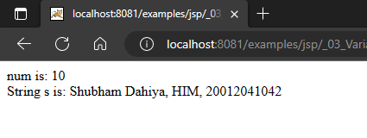

**38. Program for Function Declaration in JSP**

<html>

<body>

<%!

int cube(int n){

    return n*n*n;

}

%>

<br>

Cube of 6 is <%= cube(6) %>

</body>

</html>

**Output:**

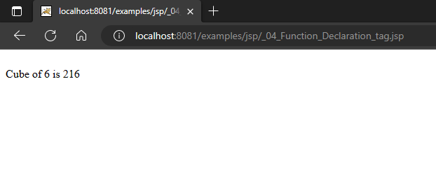

**Implicit Objects in JSP**

**39. Program for out Implicit Object in JSP**

<html>

<body>

<% out.println("hii! Shubham"); %>

<% out.print("Today is:"+java.util.Calendar.getInstance().getTime()); %>

</body>

</html>

**Output:**

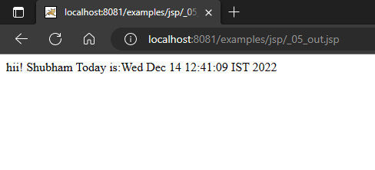

**40. Program for request implicit object in JSP**

**_06_index.html**

<html>

<body>

<form action="_06_request.jsp">

Name: <input type="text" name="name">

<br>

Age: <input type="number" name="age">

<br>

College: <input type="text" name="college">

<br>

Roll No. <input type="text" name="roll_no">

<br>

<input type="submit">

</form>

</body>

</html>

**_06_request.jsp**

<html>

<body>

Name is: <%= request.getParameter("name") %>

</body>

</html>

**Output:**

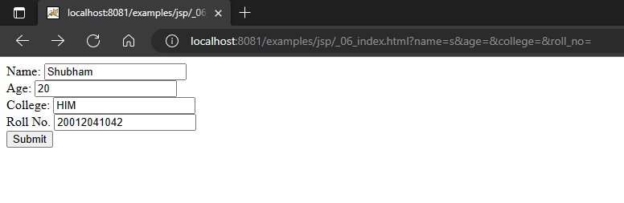

**onSubmit:**

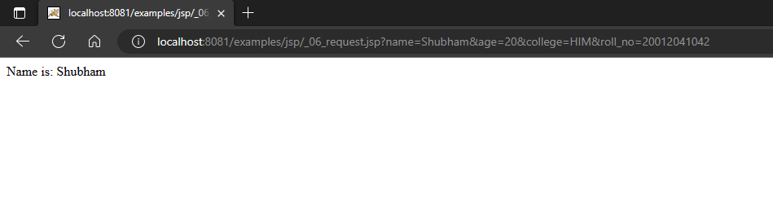

**41. Program for response Implicit Object in JSP**

**_07_index.html**

<html>

<body>

<form action="_07_response.jsp">

Name: <input type="text" name="name">

<br>

Age: <input type="number" name="age">

<br>

College: <input type="text" name="college">

<br>

Roll No. <input type="text" name="roll_no">

<br>

<input type="submit">

</form>

</body>

</html>

**_07_response.jsp**

<%

response.sendRedirect("http://www.google.com");

%>

**Output:**

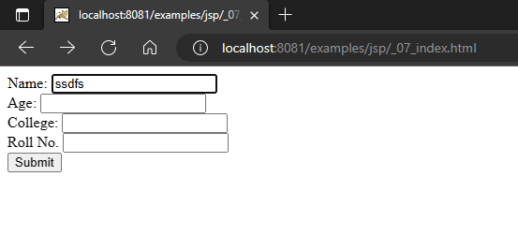

**onSubmit**

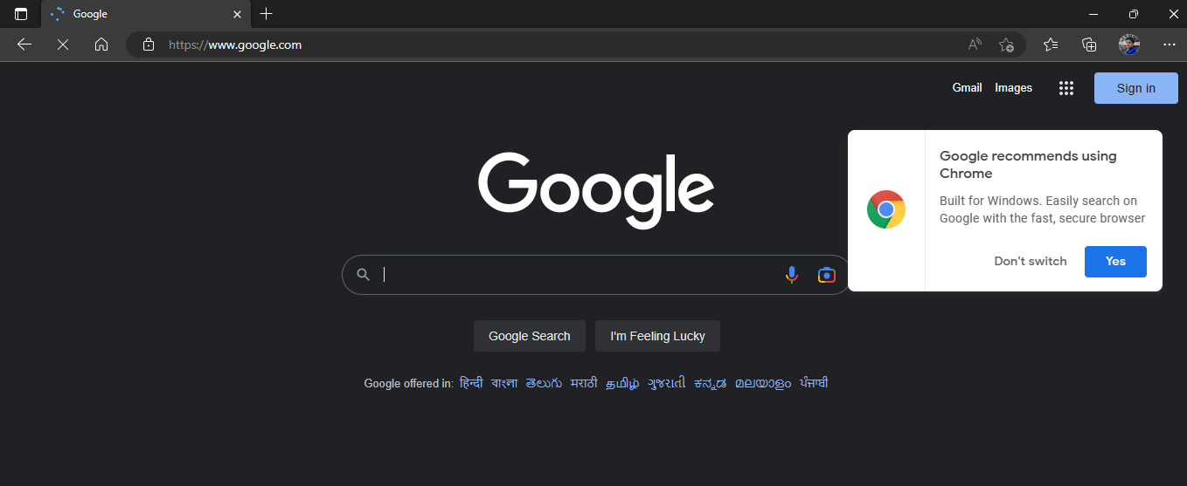

**42. Program for config Implicit Object in JSP**

**_08_index.html**

<html>

<body>

<form action="_08_config.jsp">

Name: <input type="text" name="name">

<br>

<input type="submit">

</form>

</body>

</html>

**_08_config.jsp**

<%

out.println("Hii " + request.getParameter("name"));

%>

<br>

<%

String roll_no = config.getInitParameter("roll_no");

out.println("roll_no is: "+ roll_no);

%>

**Output:**

